**Digital Forensics Applications 1a TOOLS Report.**

# Name of Tool 1: DRIVE DIGEST

## Software Tool 1: Licensing, Purpose & Validity

Drive Digest 1.2 Build 4923

The license for drive digest is by **4 Discovery**.

The license should be valid for a specified period typically one year with provisions for renewal to continue receiving technical support and updates, thus ensuring the ongoing validity and functionality of the software.

**PURPOSE:**

Drive Digest is a Windows application designed to examine files within any given folder, extracting valuable information like MD5 and SHA1 hashes to verify file integrity. It can navigate through archives to display their contents and is compatible with lengthy file paths exceeding 255 characters. Additionally, the tool categorizes files by type providing a comprehensive tally of file counts and their corresponding sizes.

## Software Tool 1: Practical Testing

Installing drive digest is straightforward, assuming you already have the .Net framework installed. Once installed, it prompts you to select a directory to create a digest. Before initiating the file listing process, you have the option to adjust settings to your preferences. For instance, you can choose to exclude the calculation of MD 5 and SHA 1 hashes if they’re unnecessary, or skip certain archive formats like ZIP7Z and RAR. In cases of compound files, Drive Digest offers the flexibility to expand them and allows you to set limits on the depth of expansion and file size. The primary interface of the application comprises multiple tabs, each containing different sets of information. The tab dedicated to file listings provides comprehensive details such as the full file path, length of the path, file extension, size category, MD5 and SHA1 hashes creation modification and access dates for each file. Additionally, it indicates whether the files are compound and whether their path exceeds the maximum length.

.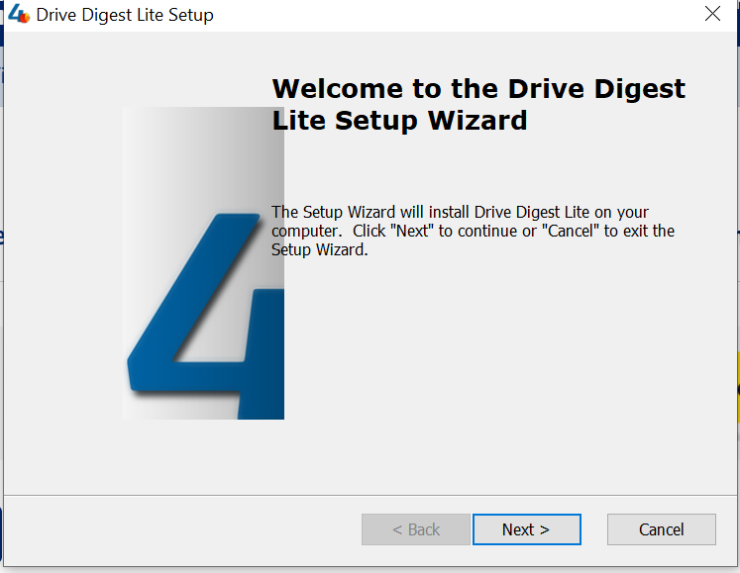

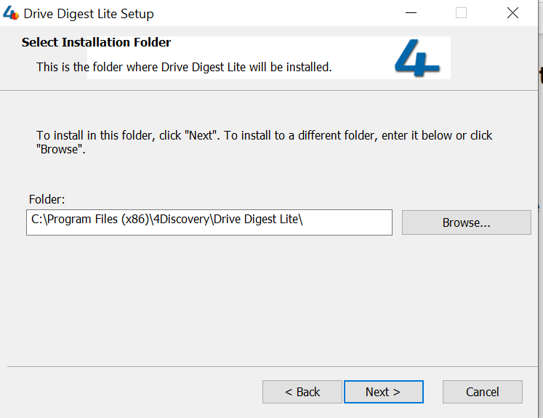

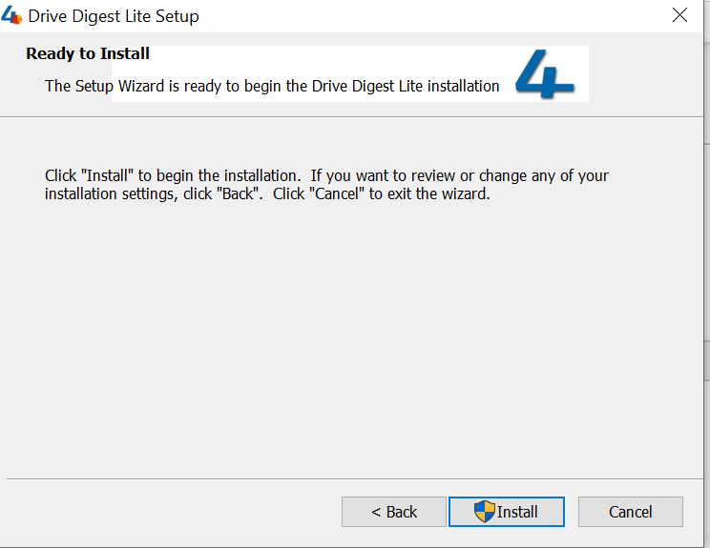

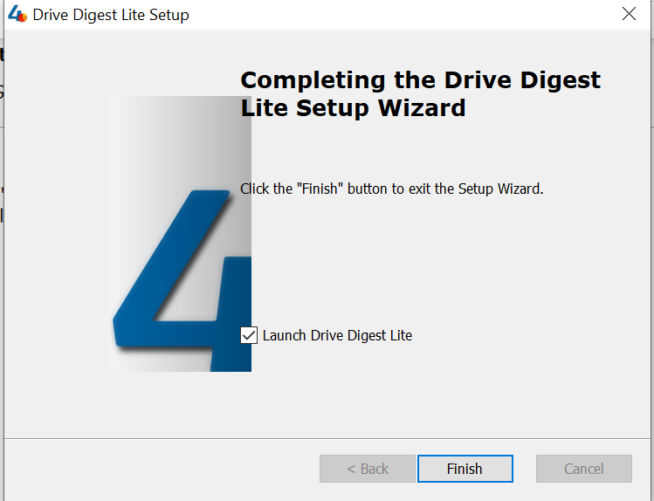

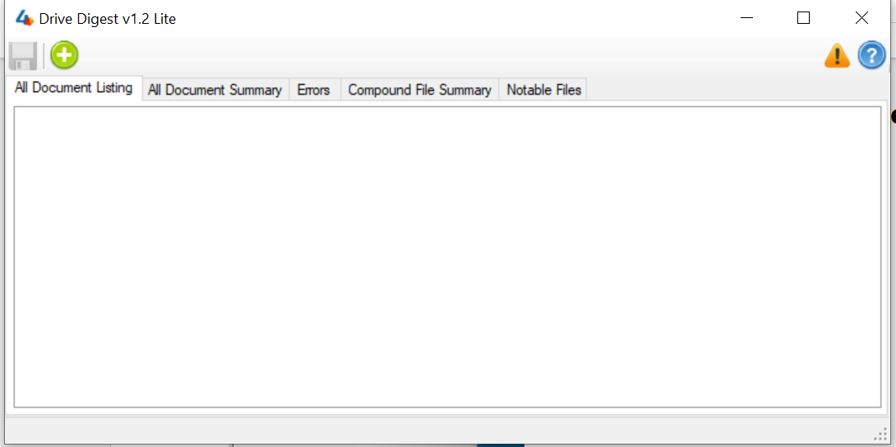

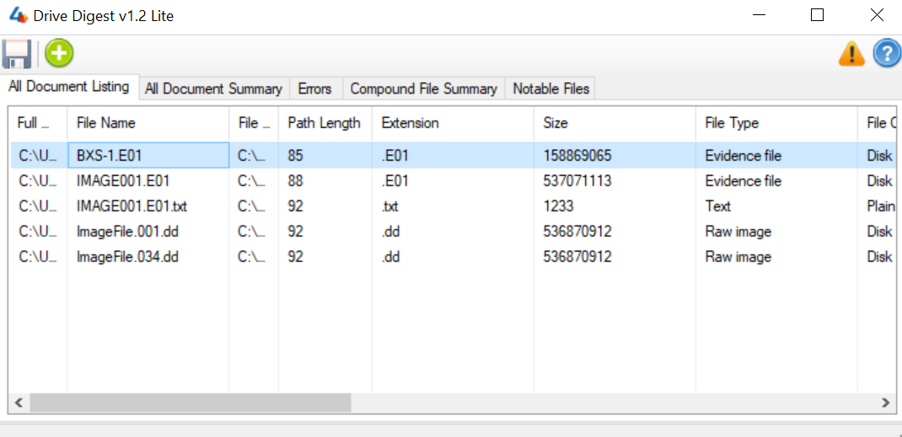

I add some files in drive digest by click on the plus sign

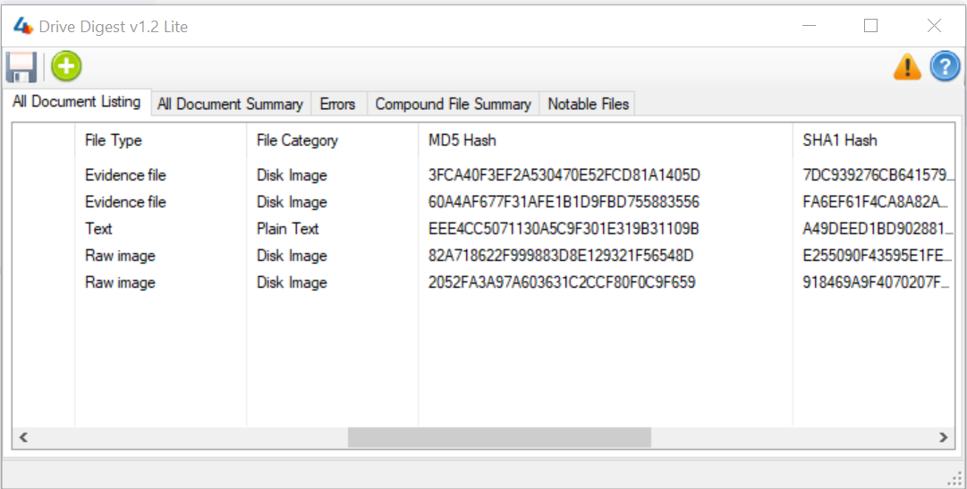

Now I got files metadata information md5 and sha1 hashes and MFT records of the file .

## Software Tool 1: Discussion & Summary:

Drive digest by 4 discovery is designed to facilitate comprehensive file analysis and integrity verification on windows systems. Its primary purpose is to analyze files within directories generating MD 5 and SHA 1 hashes for integrity checks. During practical testing drive digest showcased commendable performance in effectively analyzing files and generating digests its user-friendly interface allowed for seamless navigation and operation contributing to a positive testing experience. The tool successfully processed various file types and accurately calculated MD 5 and SHA 1 hashes, demonstrating its reliability in verifying file integrity. While drive digest excels in processing standard file formats and delivering accurate results, it may encounter challenges with complex file structures and high-volume processing. Nonetheless, its overall performance and reliability make it a valuable asset for users in need of a dependable tool for file analysis and integrity checking.

1. ***Name of Tool 2:***  **EnCase App: Credit Card Number Search With Luhn Verification.**

## Software Tool 1: Licensing, Purpose & Validity

## Software Tool 1: Practical Testing

## Software Tool 1: Discussion & Summary:

